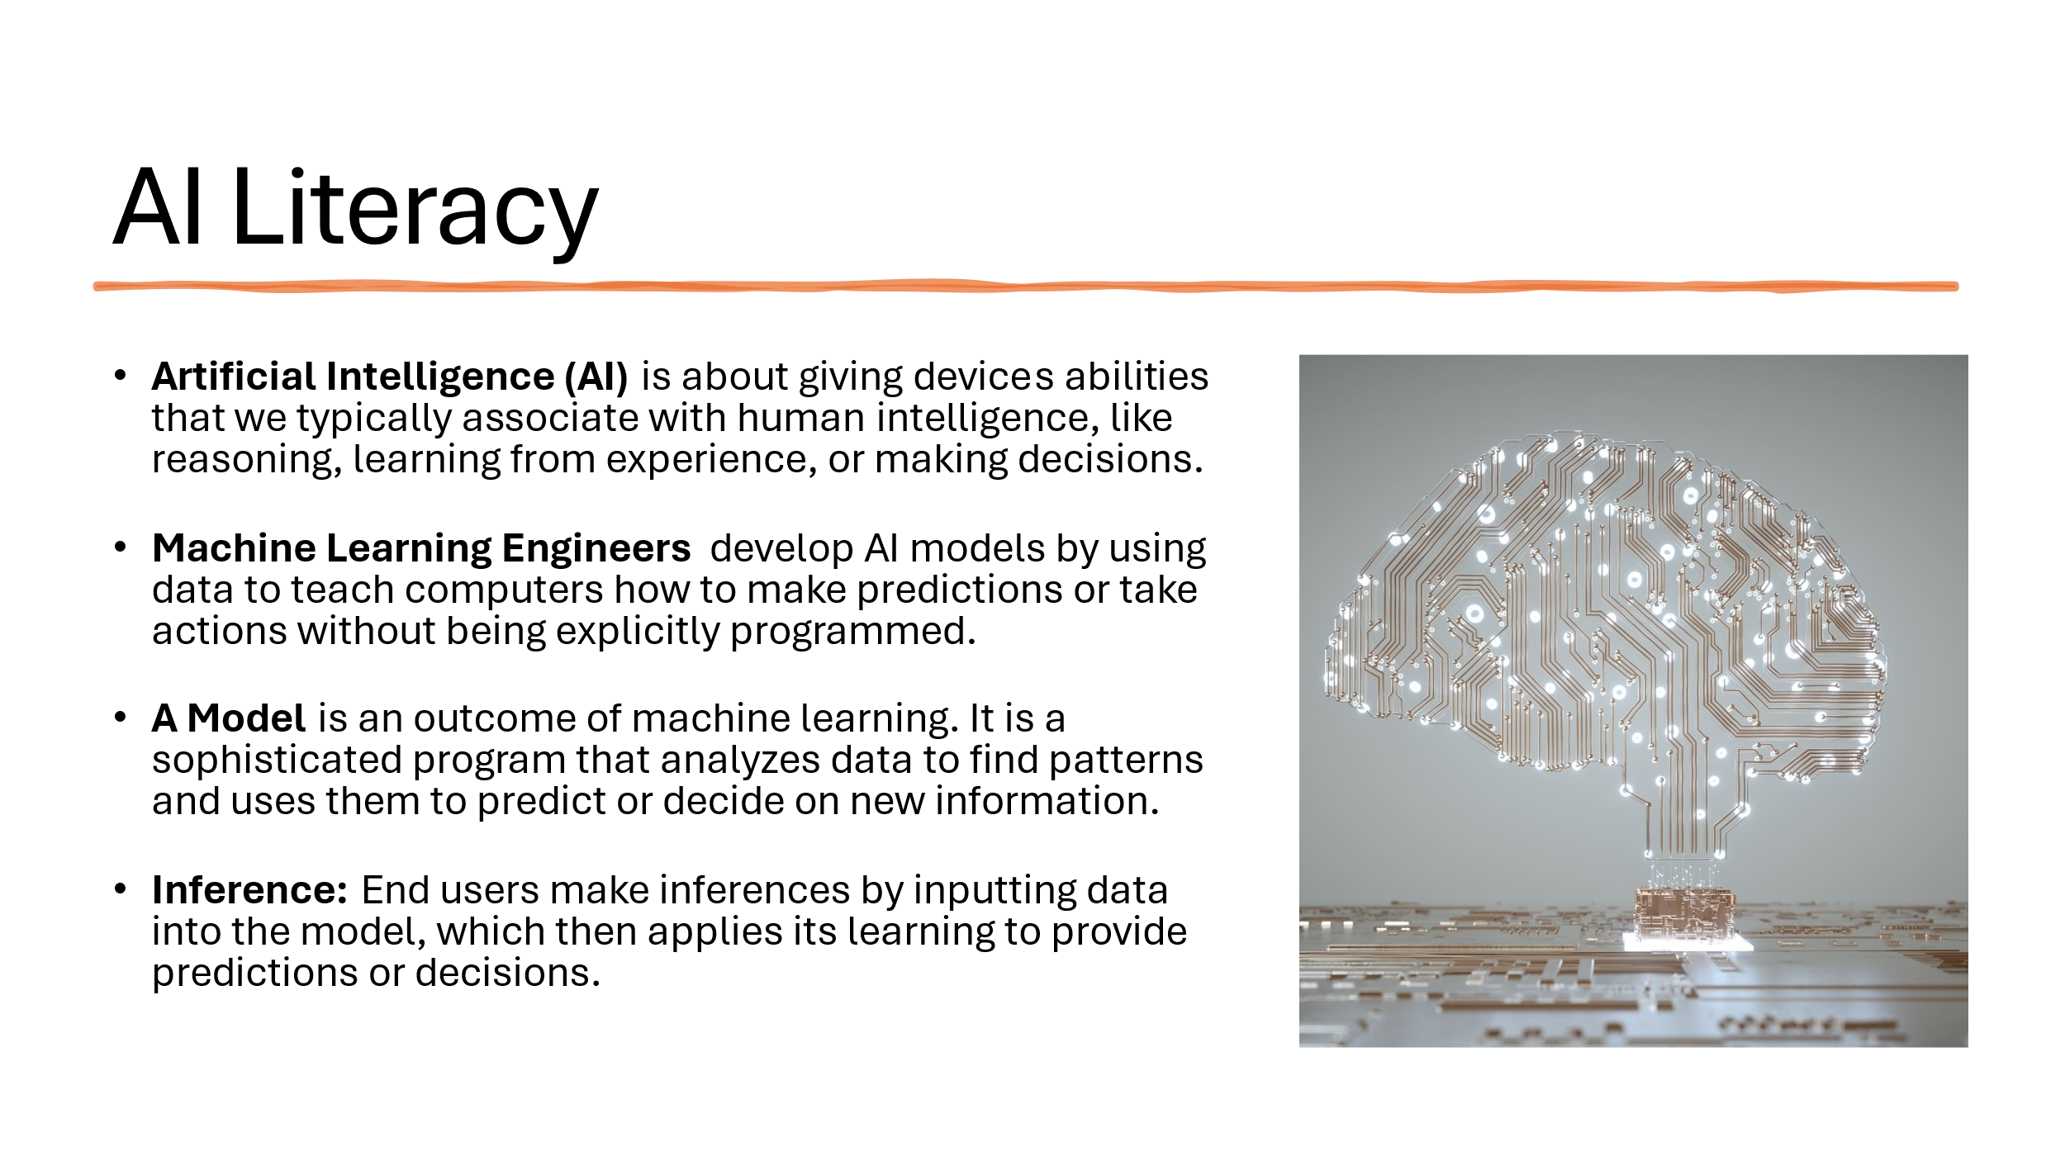

* **Shift from Digital to AI**

As we shift from the Digital Age to the AI Age, our role at Microsoft Federal becomes increasingly vital. We are not just participants but leaders in fostering AI Literacy. It's essential that we empower our customers with the knowledge to harness our platforms and services to their fullest potential, driving value and innovation.

* **AI Literacy is part of our job description**

Becoming AI literate is part our job description, regardless of our role. Artificial Intelligence gives computers capabilities that we typically attribute to humans – like reasoning, learning, and making decisions. These capabilities are encapsulated in models develop by machine learning engineers. We interact with these models daily, through the software applications and devices we rely on.

* **Benefits to government**

For our government partners, this translates to AI as a transformative force: streamlining operations, informing decision-making, and enhancing citizen services. As stewards of this technology, we have the privilege and responsibility to guide its integration and ensure it's used to enhance the public good.

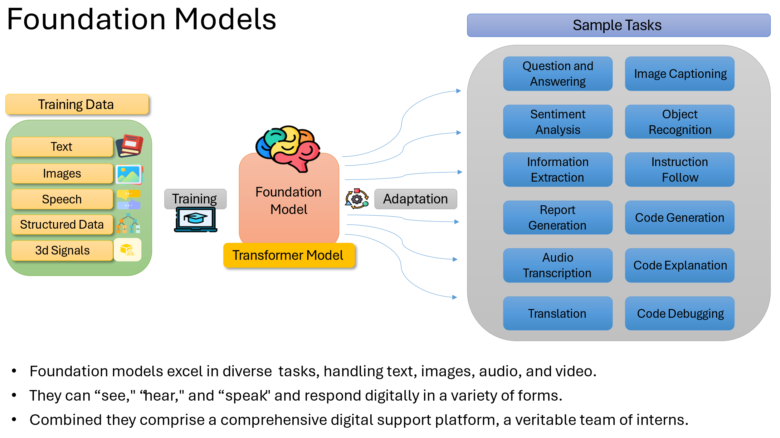

* **Revolutionary foundation models**

Enabling this transition is a new set of models that are far more capable than their predecessors. We call these 'Foundation Models,' and they are a leap forward in the AI landscape. Unlike traditional models which are often designed for specific tasks, Foundation Models are versatile powerhouses trained on diverse data types – from text and images to audio and video.

* **Versatility and human-like processing**

These models excel in a wide range of tasks because they understand and process data in a way that's closer to human cognition. They can 'see' through image recognition, 'hear' by processing speech, 'speak' by generating audio, and even 'comprehend' by understanding and translating languages. This versatility means that with a single foundational model, we can perform tasks that previously would have required multiple specialized models.

* **Adaptability and customization**

The beauty of Foundation Models lies in their adaptability. Trained on vast and varied datasets, they can be fine-tuned – or adapted – with additional data to perform specific tasks incredibly well. This adaptation process means that a single model can be customized to support different applications, from answering questions to generating reports, or from transcribing meetings to debugging code.

* **Strategic value for government partners**

For Microsoft Federal and our government partners, these models represent an opportunity to consolidate and streamline AI efforts. Think of Foundation Models as a comprehensive digital support platform – akin to a versatile team of interns ready to tackle a multitude of tasks, from the mundane to the complex. This doesn't just save on resources; it creates a more unified, intelligent, and responsive AI system.

* **Setting a new standard with AI**

As we deploy these models, we’re not just optimizing our operations; we’re setting a new standard for what AI can do. They’re not just tools but partners that enhance our ability to serve, analyze, and innovate, taking us from mere digitization to truly intelligent automation.

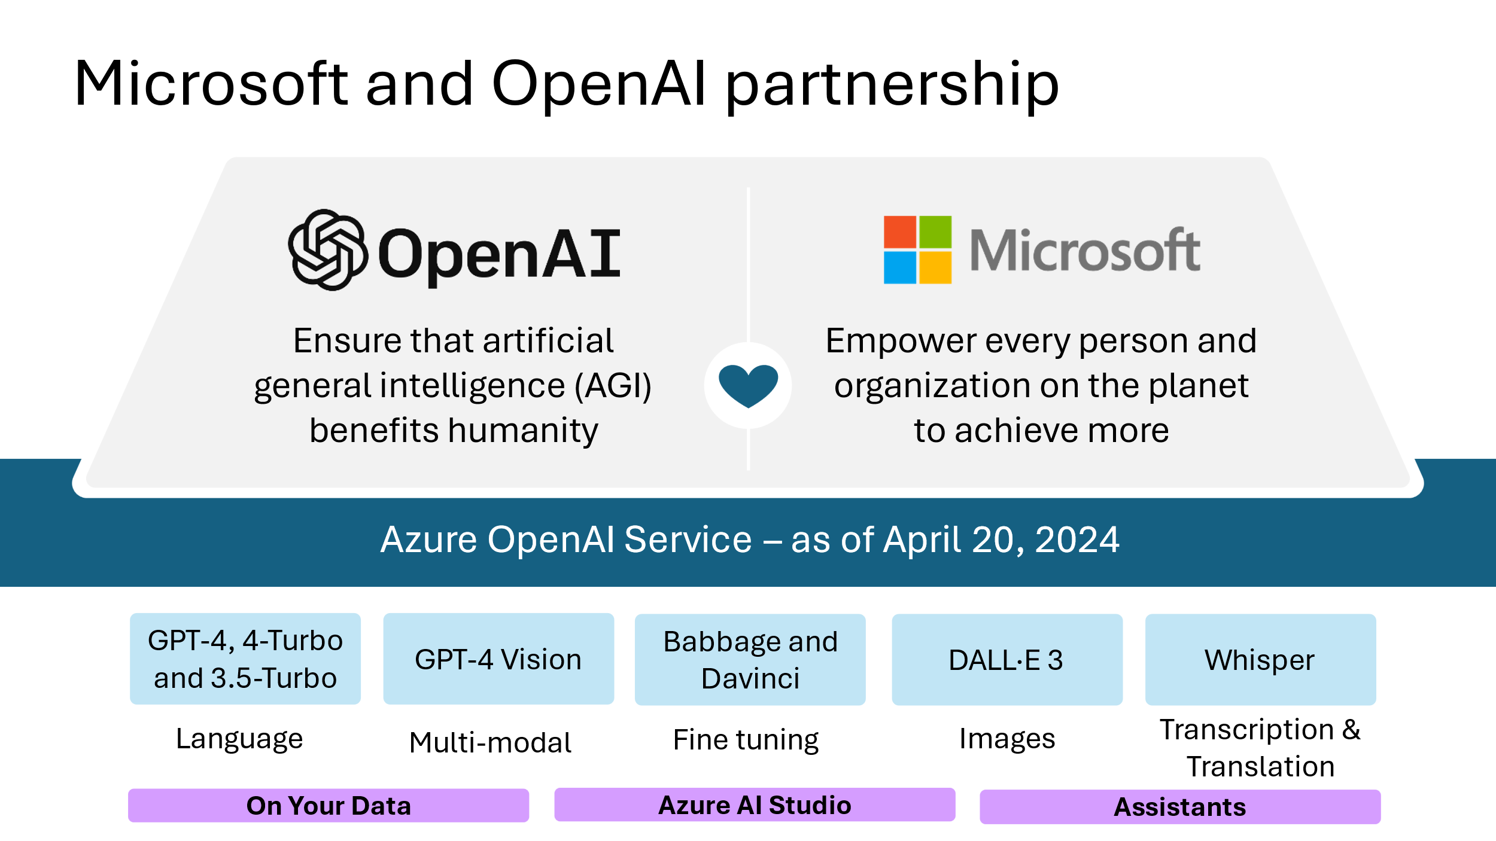

Narrative/talk track:

**The MSFT / OpenAI partnership and how we collaborate**

Microsoft has formed a partnership with OpenAI to collaborate on the development of artificial intelligence technologies. The partnership aims to accelerate the development of advanced AI systems and bring the benefits of AI to more people.

As part of the partnership, Microsoft and OpenAI have agreed to work together on several key areas, including:

* Developing AI technologies: The two companies will collaborate on the development of new AI models and algorithms, with a focus on natural language processing, computer vision, and other areas of AI.
* Building an AI computing platform: Microsoft and OpenAI will work together to build a new AI computing platform that will allow developers to easily access and use advanced AI models and algorithms.
* Advancing AI research: The two companies will also collaborate on a range of research projects aimed at advancing the state of the art in AI.
* Making AI more accessible: The partnership aims to make AI more accessible to a wider range of developers and organizations, in order to bring the benefits of AI to more people.

Microsoft has also announced it will use OpenAI's GPT-3 technology to add more capabilities to its products such as Cortana, Power Virtual Agents and Dynamics 365.

Additionally, Microsoft has also made an investment in OpenAI, allowing the company to use Microsoft Azure as its preferred cloud platform, and allowing OpenAI to tap into the vast resources of Microsoft to accelerate its research. This partnership gives OpenAI the ability to scale its models and services on Azure and make them more widely available to customers.

Overall, the partnership between Microsoft and OpenAI aims to accelerate the development and use of advanced AI technologies, with a focus on making AI more accessible to developers and organizations, in order to bring the benefits of AI to more people.